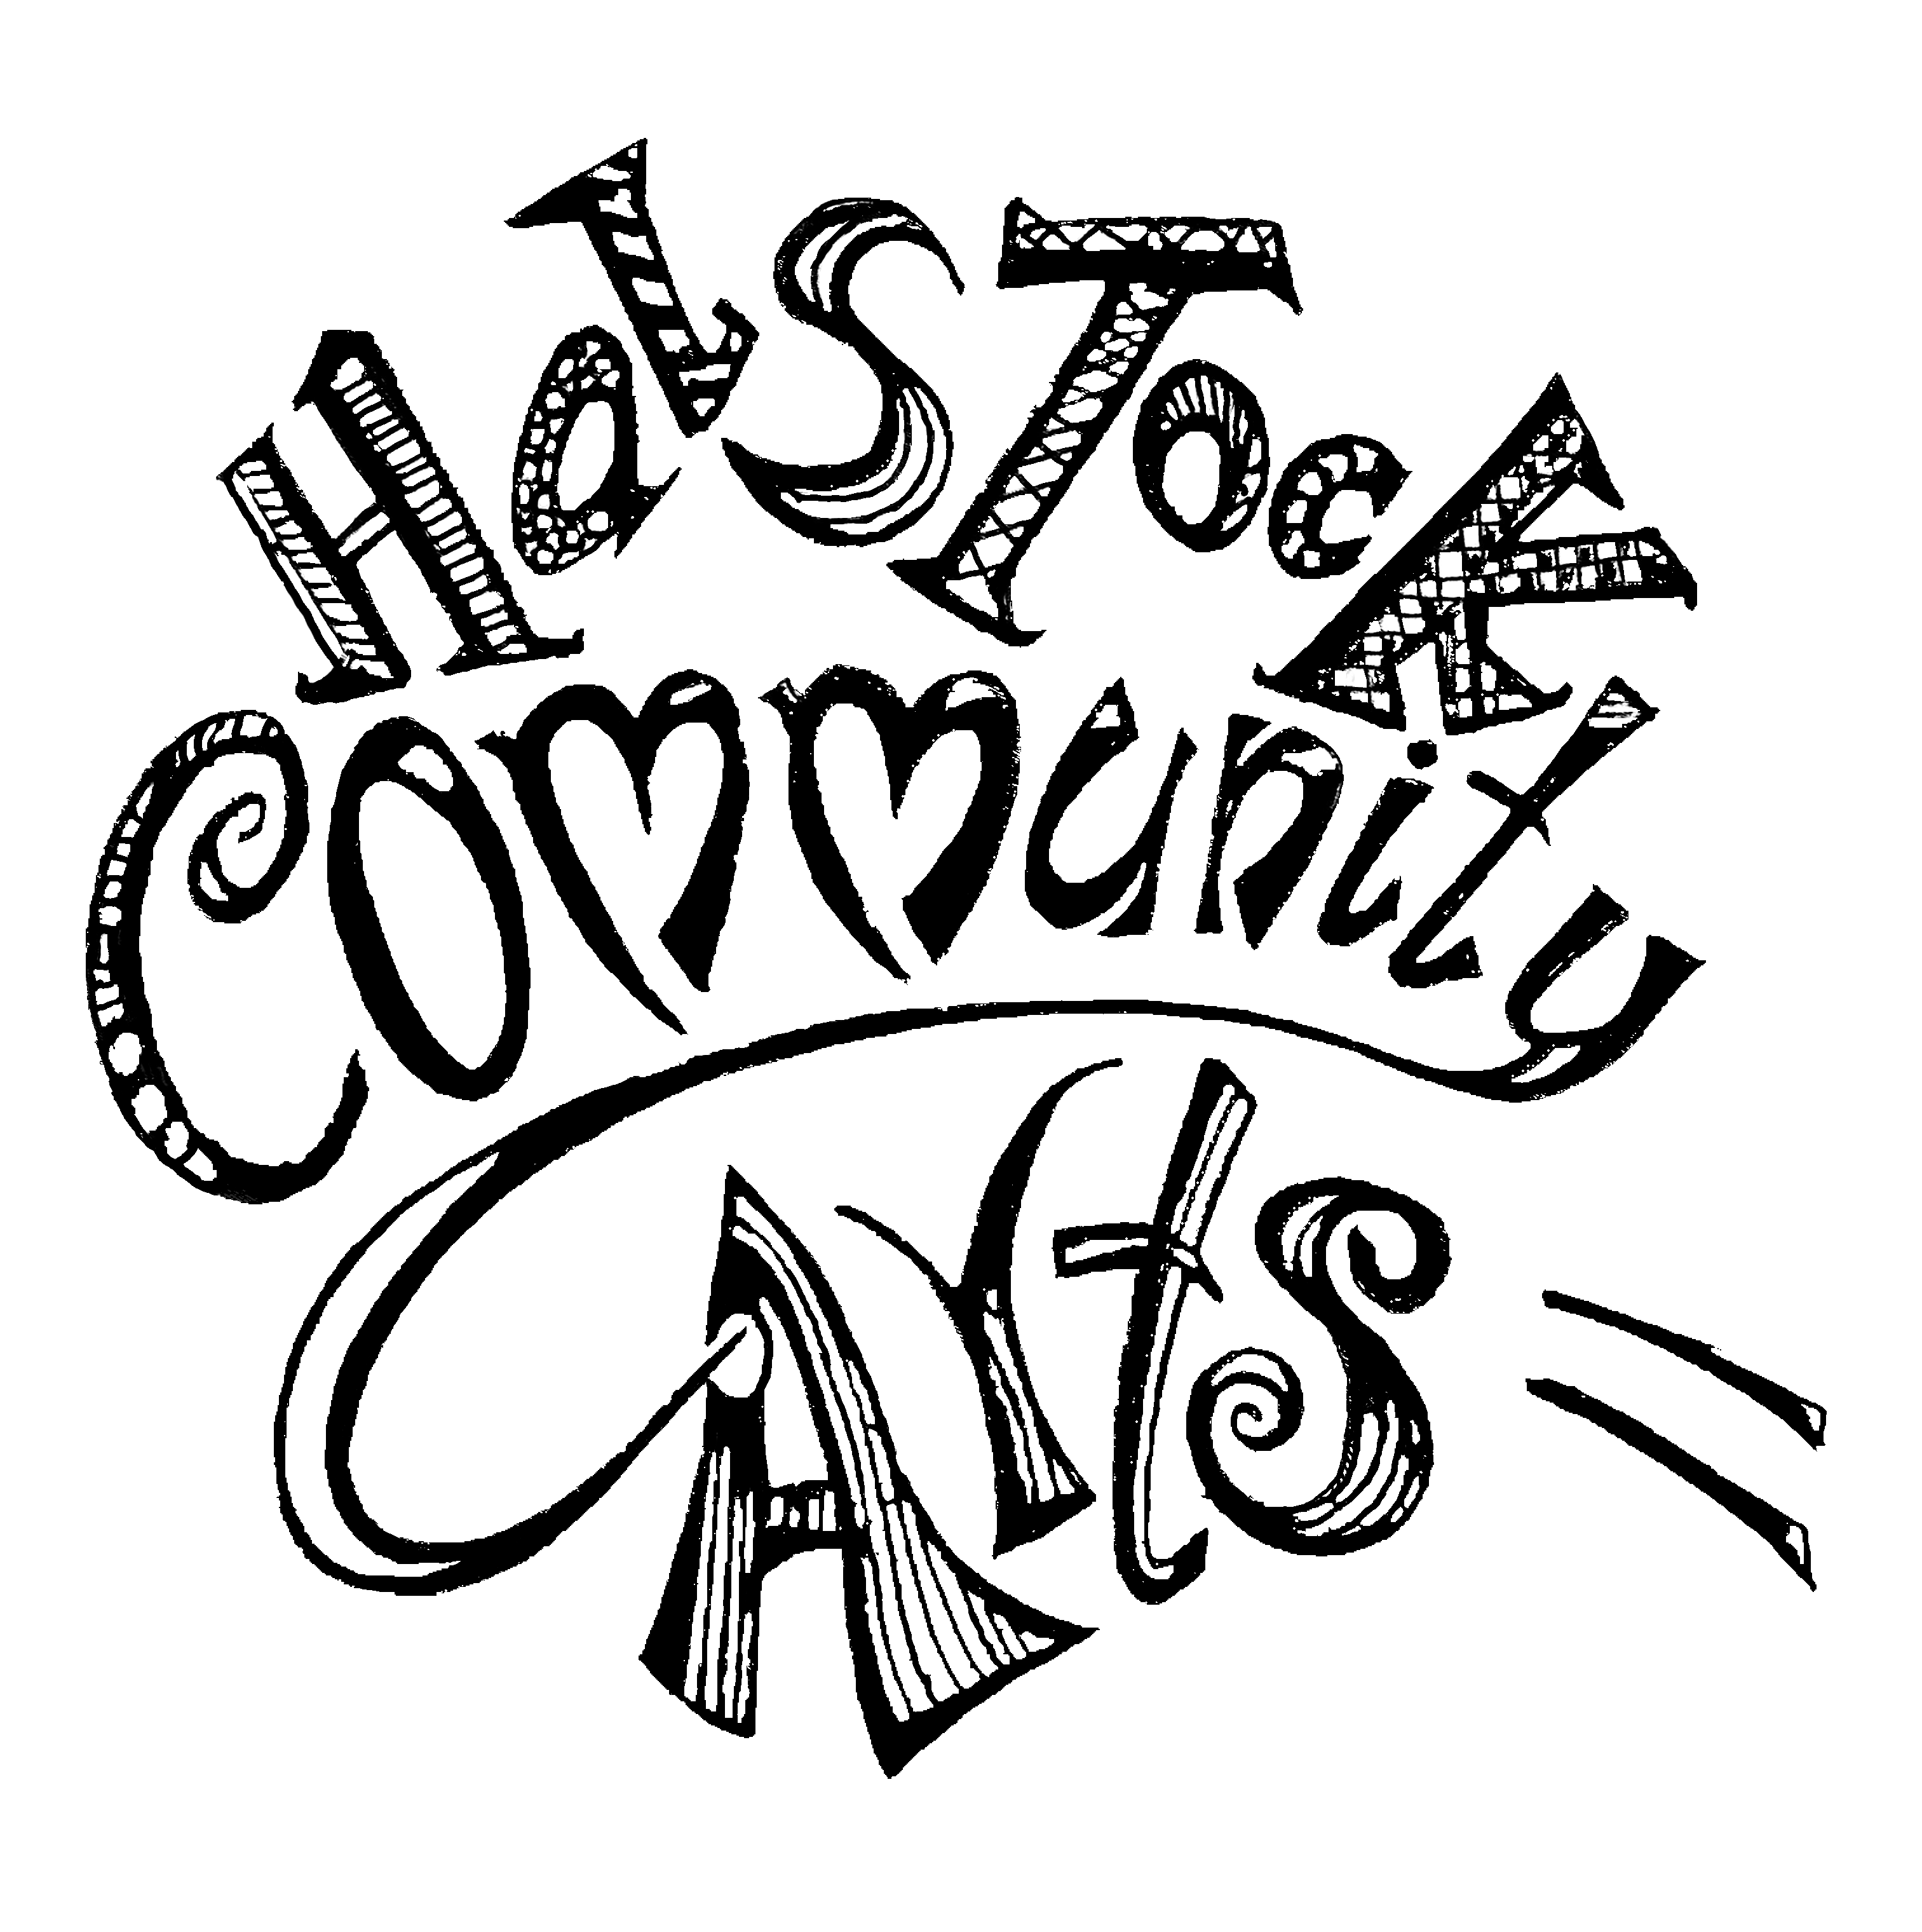

**Halstock Community Arts Bursary Application 2024**

**Full Name:**

**Address:**

**Email Address:**

**Contact number:**

**Date of birth if under 25:**

**Brief summary of your artistic experience to date:**

Maximum 300 words

**Details of the project that you intend to use the Bursary funding for:**

Maximum 300 words

**Names and contact details of two referees:**

Name:

Email address:

Phone contact:

Name:

Email address:

Phone contact:

Signature………………………………………………………………………………………………….



**Halstock Community Arts (HCA) Bursaries 2024**

(halstockcommunityarts@gmail.com)

**Terms and Conditions**

**1. The Bursary Scheme:**

The HCA Committee will be awarding up to two £400 Arts Bursaries to selected candidates in 2024.

**2. Eligibility:**

Applicants must live or work within a 20 mile radius of Halstock, Dorset. Priority for one of the awards will be given to applicants under the age of 25.

**3. Selection Process:**

The decision as to who will receive the Bursary funding will be made by the HCA Committee and their decision will be final

**4. Publicity:**

Bursary award recipients are deemed to agree by virtue of their application to the publication of their name and artistic details as well as to the use of their photograph for the purposes of informing the local community of the award decisions.

HCA will also require photographs and a short description/review of the selected project once completed.

**5. References:**

Applicants must provide the names of two independent referees. Family members of the applicants are excluded from providing a reference.

**6. Payment of the awards:**

Successful applicants will be required to provide the name and account details of their bank account into which payments will be made. The account must be with a recognised bank in the UK.

**Closing date for applications 31st December 2024**